Toronto is a massive metropolitan hub of business, technology, and life, being the largest city in Canada (fourth largest in the whole of North America), with over 6.4 million inhabitants and almost 100,000 new arrivals annually. While it boasts six-internationally recognized colleges and five world-renowned universities, many inhabitants are still in the beginning stages of their education with approx. 246,000 students in elementary and secondary schools aside from the 140,000 more in adult and continuing education programs, and 1,400 education centers and related businesses throughout the city. Sexual education is an invaluable element to any student's understanding of the world and themselves, and stigmas and misunderstanding frequently leave them with erroneous impressions of the dangers and responsibilities, as well as tools for dealing with them, that come with sexual maturity.

When parents are searching for a good place to raise their children and get them an education, there are a multitude of factors they must consider. Parents want more than anything to know that their children will be informed and safe about their health as well as their grades, especially as they grow and more independent as they age and seek out new experiences. The transition to sexual maturity and the responsibility and risks that come with it are a massive source of anxiety for parents and young adults alike, and they don’t always have access to valuable knowledge about sex or care in the event of This report will seek to organize and clearly present information of where various sexual health centers are distributed throughout the city of Toronto as well as their proximity to educational centers. Also included and explored will be things such as contact information, the eligibility criteria to qualify for care, and the specific services provided by these centers.

The findings of this project will hopefully be of use to:

-Parents and guardians looking for nearby sources of reliable information, help and care for their children about their sexual experiences and potential problems stemming from them, especially ones located nearby to their places of residence or education.

-Teenagers looking for the same information since parents or guardians might not be best equipped to explain or help them through problems they may be experiencing.

-Schools that might seek to better inform their students about what they might encounter during their scholastic careers or later in life, and seek resources to help for sexual health classes and want their students to know about outside resources and how they can be accessed.

The geographical data of Toronto, such neighbourhood, data, and postal code were scraped from Wikipedia and coordinates were downloaded through the Coursera portal. Information on and the locations of educational facilities and youth sexual health service centers were downloaded as datasets from the Toronto open data portal. The latitude and longitude data for the sexual health centers was acquired from latlong.net.

In the data for the educational facilities, there is name data for the facility and school board, location data such as address, postal code, municipality, latitude and longitude. The data for the sexual health service centers consists of name and location data like the agency name, address, latitude and longitude, and neighbourhood, and accessibility information such as phone number, email address, website, description of services, eligibility criteria, application process, business hours, legal status, and language. These could all prove crucial information for anyone seeking aid from any one of these organizations and wanting to pick the best one available. When placed together, these pools of data could provide crucial insight into what the safest choice of school as far as accessibility to these resources would be, as well as any persons that might solicit resources from these organizations in any capacity.I mapped both datasets latitude and longitude coordinates onto a map with different markers to differentiate different types of each facility: educational or sexual health. In the services description column for the sexual health centers, I searched for the most common and useful keywords and, using that, created another dataframe that flagged whether each facility listed each of the keywords in their description for ease of perusal and assessment of services. Each of the resulting points was labelled with information such as facility name, address, physical accessibility information, and eligibility criteria.

Using the map created with the data, we are able to see that most of the sexual health service centers are located in the southern-center area of Toronto. Given that many potential clients might not have easy access to one of these centers, they would be well advised to take note which ones are nearest them based on their needs and the services these centers provide.While this data and these tools, the map and dataframes, might prove useful for those searching for a broad picture of where to go for sexual health services in the city of Toronto, it would be more helpful for future projects if there were more complete data on the sexual health issues being experienced by which demographics of the population in which areas, such that recommendations could be made even more precisely catered to an individuals needs. This project didn’t precisely involve any machine learning or analysis of trends, instead being more a meta analysis on existing datasets to try and provide a helpful-to-the-layman view of what might be a sensitive but important issue. In the future, as discussed in the future directions suggestions, it would be far more fruitful to perhaps explore the impact of these health centers on combating various sexual health problems over time in their given areas or in Toronto as a whole.

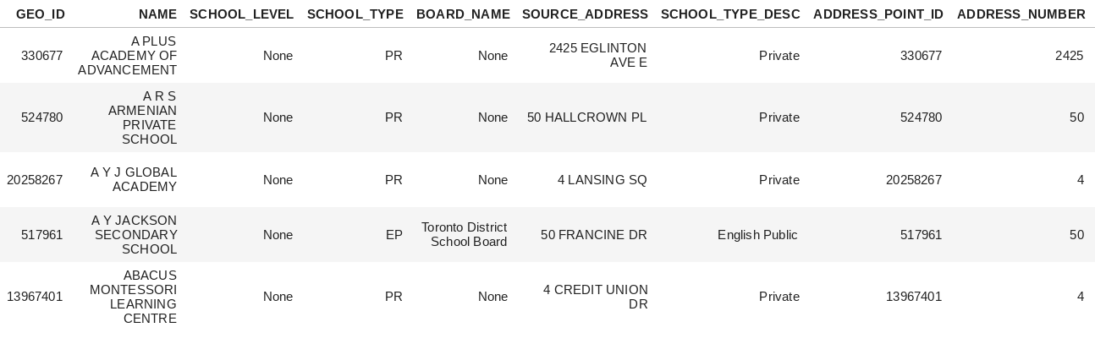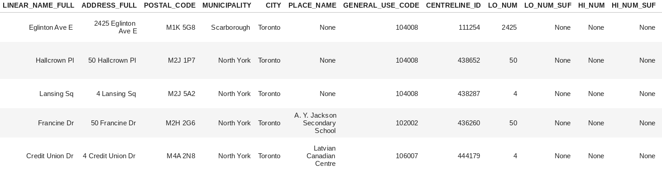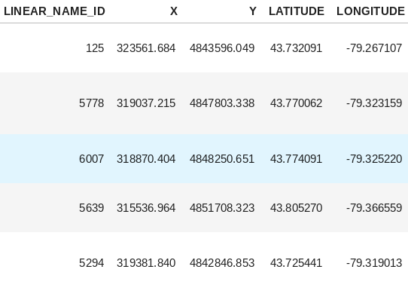

Sexual Health Centers:

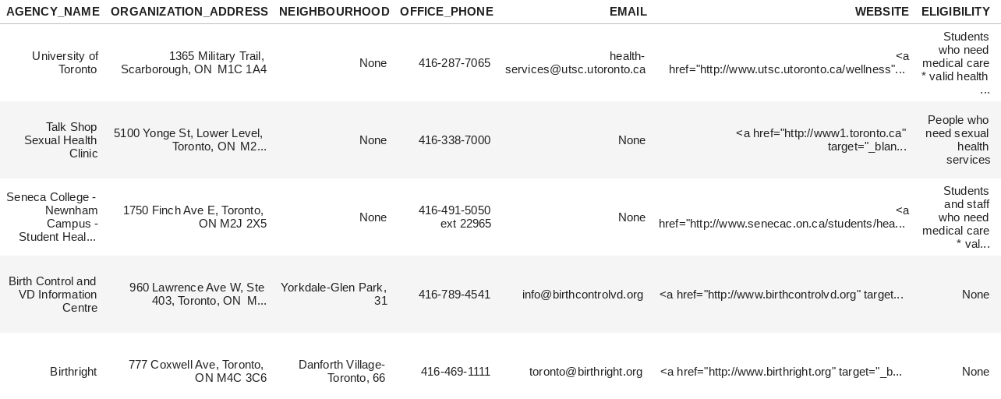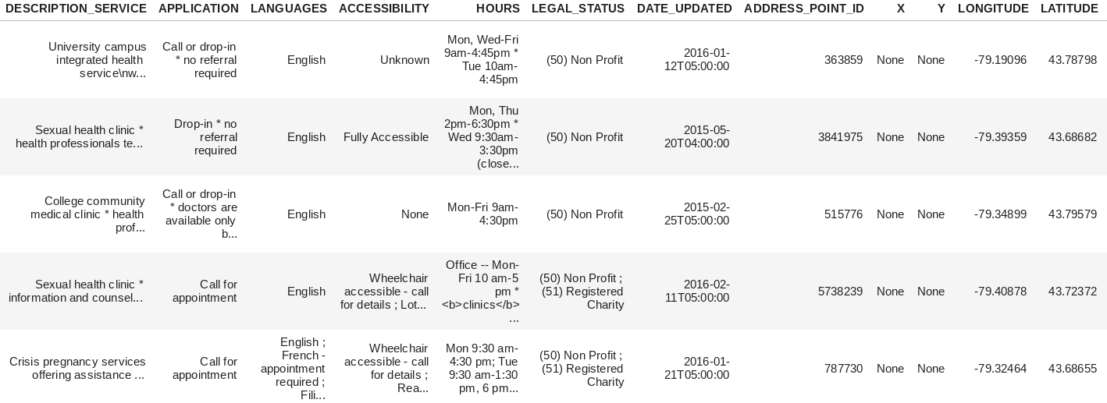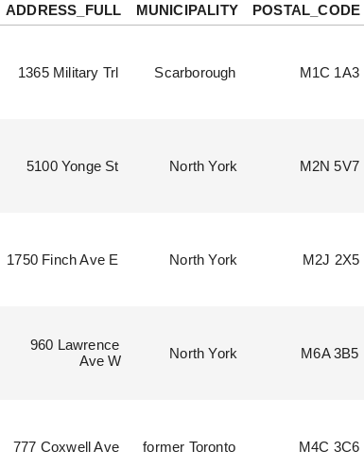

Data Sources:

<https://www.latlong.net/convert-address-to-lat-long.html>

<https://open.toronto.ca/dataset/school-locations-all-types/>

<https://open.toronto.ca/dataset/wellbeing-youth-sexual-health-services/>

<https://torontoglobal.ca/Discover-Toronto-region/Toronto-region-quick-facts>

<https://www.toronto.ca/business-economy/industry-sector-support/education/>